**CSE 523 Machine Learning Winter 2022**

Progress Report :

**Vehicle Detection using HOG-SVM**

Group Name :

**FOUR**

**Date: 13th April, 2022**

Group Members -

| Darsh Patel | AU1940150 |
| --- | --- |
| Dev Jani | AU1940045 |
| Chirayu Vithalani | AU1940160 |
| Siddharth Agrawal | AU2020091 |

**1) Tasks Performed in the week**

* Replicated a project to gain insights on how to improve accuracy on lane detection using hough transform
* Better accuracy for hough transform lane detection
* Less false positives for hough transform lane detection
* Tuning parameters for hough transform and canny edge detector for lane transform
* Applying masks for suppressing false positives

**2) Outcomes of the tasks performed**

Replicated project result:

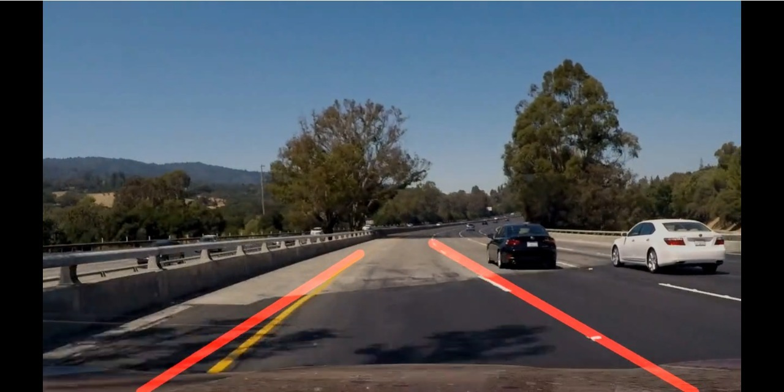

**Our own implementation:**

Canny edge detector:

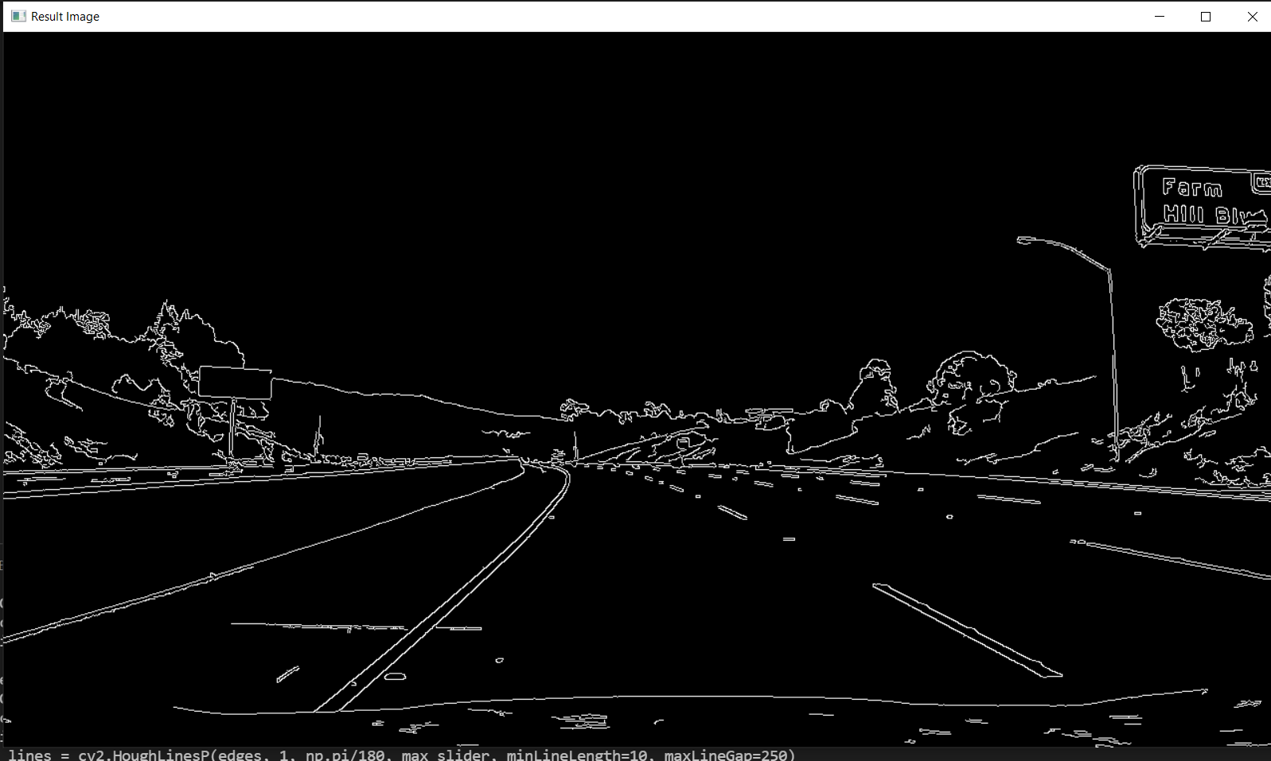

Hough transform line detection:

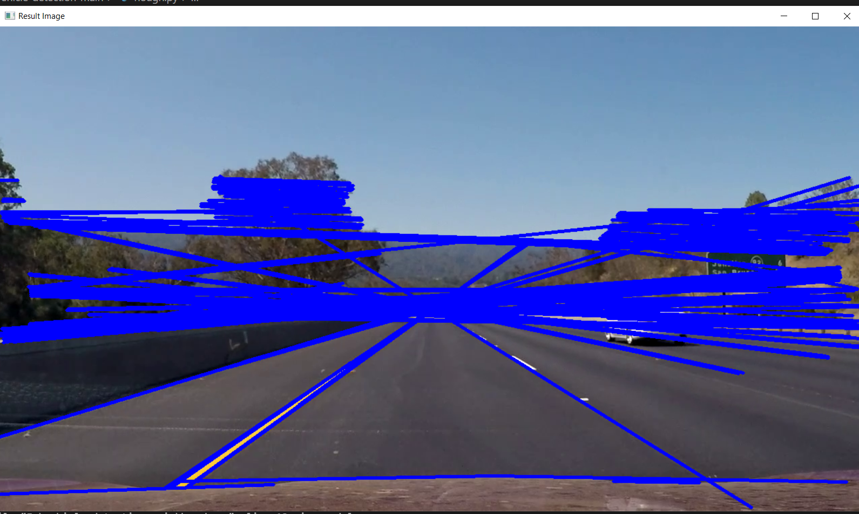

As we can see we were getting poor accuracy till last week with a high number of false positives.

Since we can expect the lane in which we are driving to converge to the vanishing point, applying such a mask helps reduce false positives:

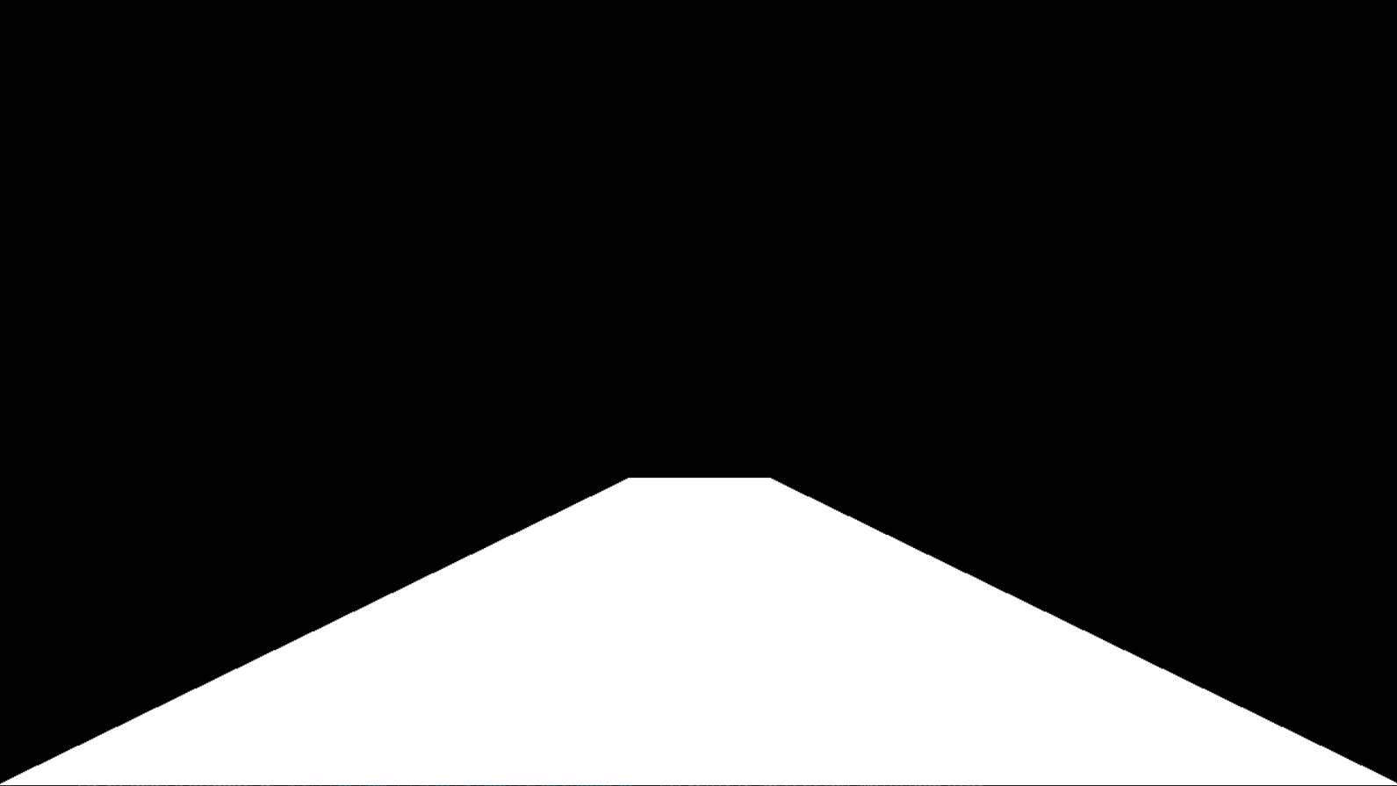

*Image mask*

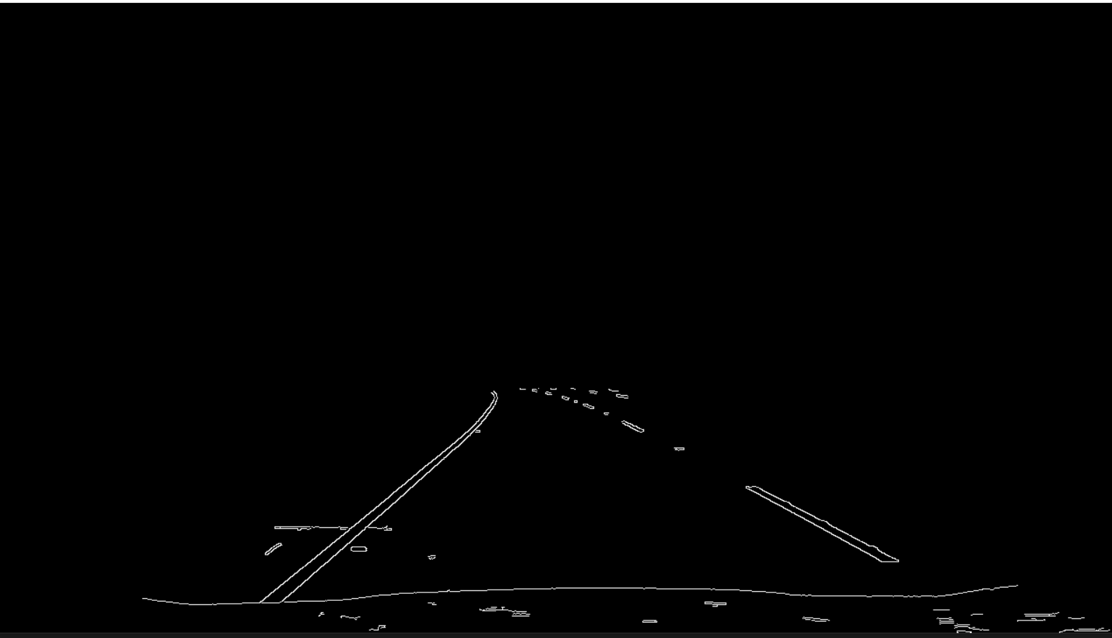

*Masked image*

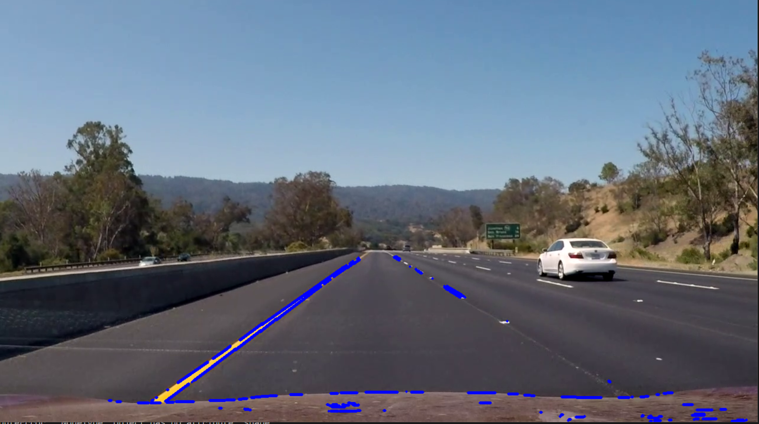

*Hough transform line detection on masked image without hyperparameter tuning*

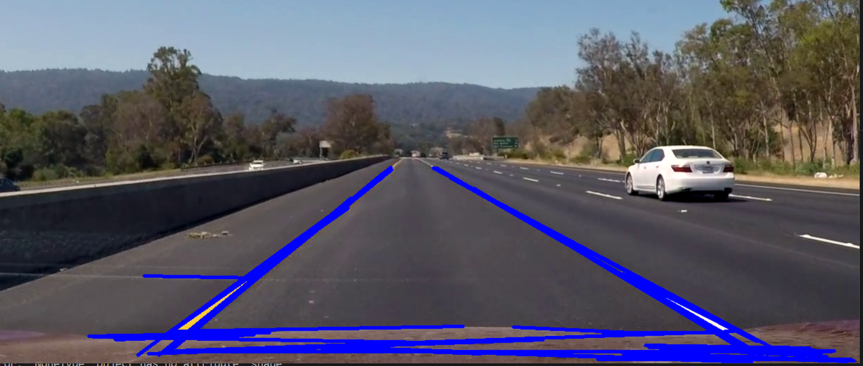

*Hough transform line detection on masked image after hyperparameter tuning*

Further refining of mask:

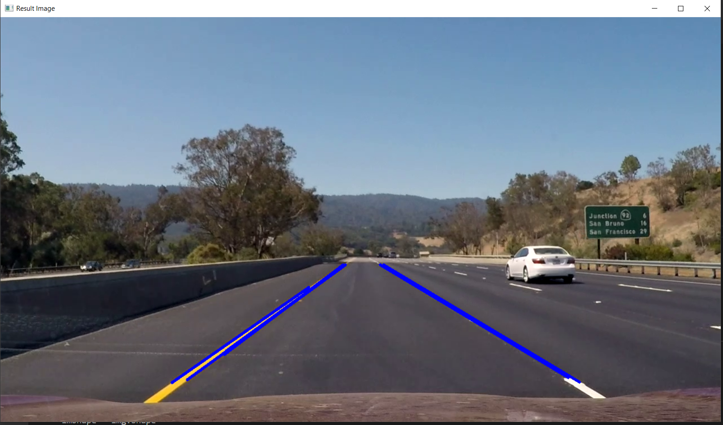

**3) Tasks to be performed in the upcoming week**

* Further reduce false positives

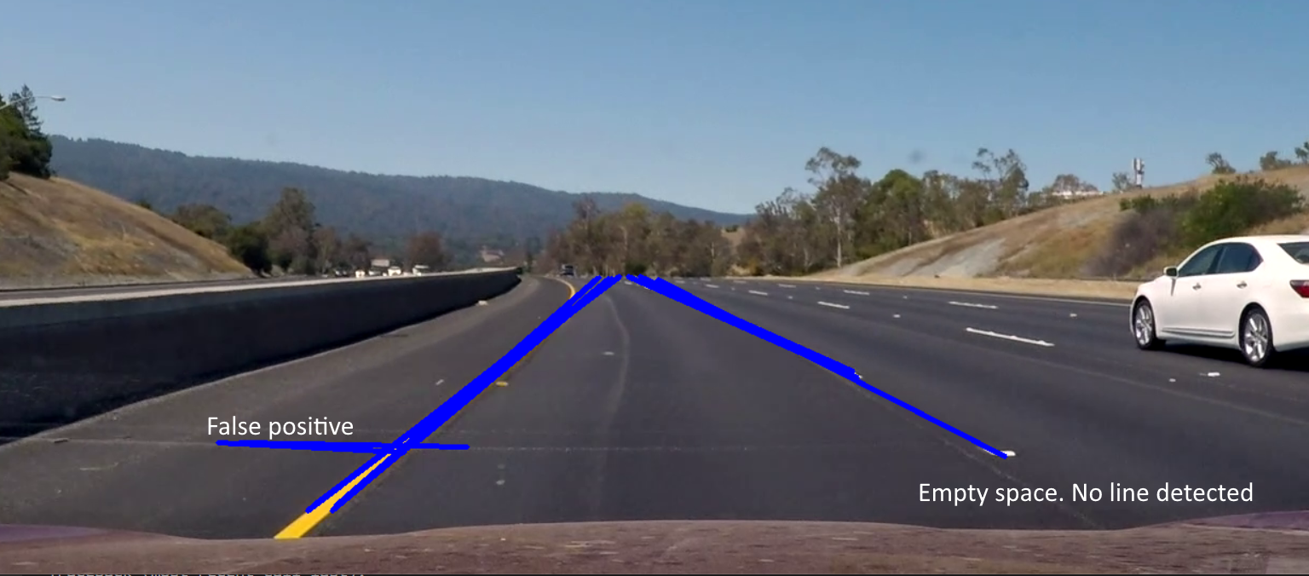

*Issues to fix (certain false positives and false negatives)*

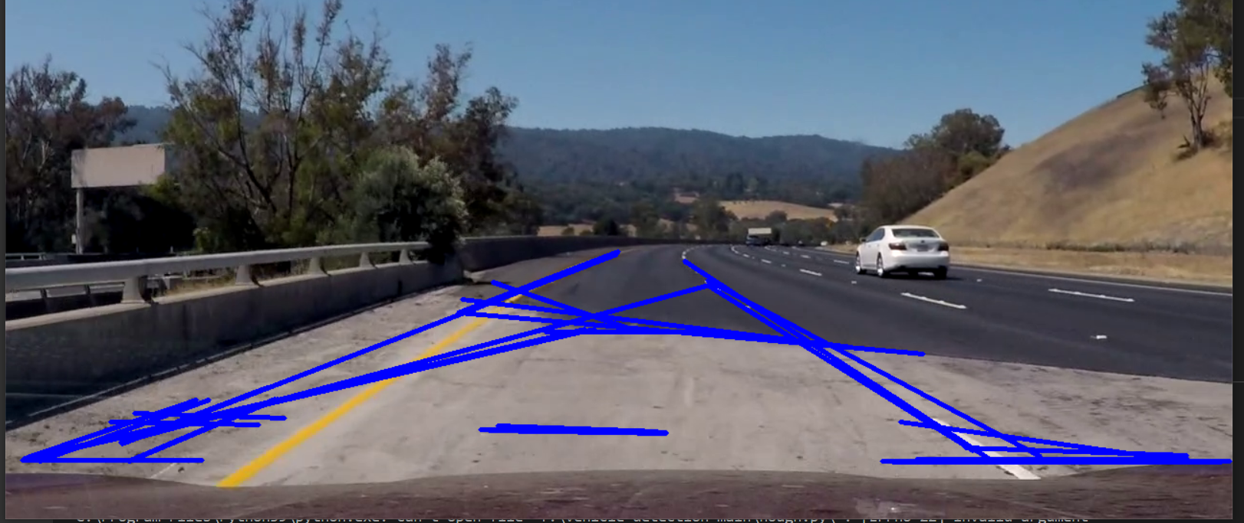

*Errors due to shadows on the road*

* Reduce double/triple overlapping/close edges (some kind of non maximal suppression for the linemap is required)
* Combine lane detection and vehicle detection